V.L Memorial Public School
475 Vijay Nagar
Chapter - 7 - Questions - Class6th - Science
CLASS 06 - SCIENCE (CURIOSITY)

 | Section A
1 | Why is a laboratory thermometer held vertically while measuring temperature?  a) To increase water temperature  b) To prevent liquid movement  c) To follow correct measurement  d) To keep it tilted | [1]
2 | Why is it important to measure temperature accurately in scientific experiments?  a) To save time  b) To make experiments faster  c) To use expensive equipment  d) Ensure accurate results | [1]
3 | Why might different thermometers give slightly different readings for the same temperature?  a) Because of different scales used  b) Based on the user’s preference  c) Because they are broken  d) Due to varying weather conditions | [1]
4 | What should be done to the digital thermometer before and after use?  a) Wash the tip with soap and water  b) Freeze it  c) Clean it with alcohol  d) Boil it | [1]
5 | Which scale is primarily used for scientific temperature measurements?  a) Fahrenheit  b) Kelvin  c) Both Celsius and Fahrenheit  d) Celsius | [1]
6 | How should a laboratory thermometer be held when measuring temperature?  a) Horizontally  b) At a 45 - degree angle  c) Vertically  d) Upside down | [1]
7 | What is the unit of temperature in the Kelvin scale?  a) Degree Kelvin  b) Degree Celsius  c) Degree Fahrenheit  d) Kelvin | [1]
8 | What liquid is commonly used in laboratory thermometers besides mercury?  a) Acetone  b) Water  c) Alcohol  d) Glycerin | [1]
9 | What is the term used to describe the measure of hotness or coldness of a body?  a) Humidity  b) Energy  c) Pressure  d) Temperature | [1]
10 | How is body temperature measured using a digital thermometer?  a) From a distance of one meter  b) By inserting into the ear canal  c) By placing it on the skin surface  d) By measuring forehead temperature | [1]
11 | 37$​^{o}$ C is the same temperature as ________.  a) 98.4$​^{o}$ F  b) 98.6$​^{o}$ F  c) 97.6$​^{o}$ F  d) 97.4$​^{o}$ F | [1]
12 | What should be avoided when handling a laboratory thermometer?  a) Keeping it vertical  b) Reading it at eye level  c) Holding it by the bulb  d) Immersing it in the substance | [1]
13 | Which type of thermometer is used to measure the temperature of the human body?  a) Weather Thermometer  b) Digital Thermometer  c) Clinical Thermometer  d) Laboratory Thermometer | [1]
14 | How does touching someone’s forehead compare to using a thermometer for checking fever?  a) Forehead touch gives a more accurate reading  b) Thermometers provide definite numerical data  c) Both methods give identical results  d) Touching is always less hygienic | [1]
15 | Why are digital thermometers replacing mercury thermometers?  a) They are less accurate  b) They are easier to break.  c) They are saferand easier to read  d) They are cheaper and easier to break | [1]
16 | Which thermometer is not typically used to measure human body temperature?  a) Clinical Thermometer  b) Infrared Thermometer  c) Digital Thermometer  d) Laboratory Thermometer | [1]
17 | Why is washing the thermometer before and after use important?  a) It makes the thermometer warmer  b) It has no considerable effect  c) Ensures no temperature errors, maintains hygiene  d) Helps the thermometer break easily | [1]
18 | What is the freezing point of water on the Celsius scale?  a) 32°C  b) 0°C  c) - 273.15°C  d) 100°C | [1]
19 | What was Anna Mani known for?  a) Discovering infrared thermometers  b) Creating the first digital thermometer  c) Contributions to meteorology and weather instruments  d) Developing the Kelvin scale | [1]
20 | What happens to the temperature reading when a body is hotter?  a) Fluctuates  b) Decreases  c) Increases  d) Remains constant | [1]
21 | Assertion (A): Clinical thermometers are used for measuring the temperature of boiling water.  Reason (R): Clinical thermometers have a limited range suitable only for measuring human body temperature.  a) Both A and R are true and R is the correct explanation of A.  b) Both A and R are true but R is not the correct explanation of A.  c) A is true but R is false.  d) A is false but R is true. | [1]
22 | Assertion (A): Digital thermometers are replacing mercury thermometers.  Reason (R): Mercury is a toxic substance, and digital thermometers provide easier - to - read displays.  a) Both A and R are true and R is the correct explanation of A.  b) Both A and R are true but R is not the correct explanation of A.  c) A is true but R is false.  d) A is false but R is true. | [1]
23 | Assertion (A): Infrared thermometers were widely used during the COVID - 19 pandemic.  Reason (R): Infrared thermometers can measure temperature without direct contact with the body.  a) Both A and R are true and R is the correct explanation of A.  b) Both A and R are true but R is not the correct explanation of A.  c) A is true but R is false.  d) A is false but R is true. | [1]
24 | Discuss two reasons why non - contact infrared thermometers became prominent during the COVID - 19 pandemic. | [1]
25 | Explain the role of temperature difference in comparing two bodies. | [1]
26 | Describe the primary function of a thermometer. | [1]
27 | Why is a digital thermometer considered safer than a mercury thermometer? | [1]
28 | What is the purpose of using clinical thermometers? | [1]
29 | How can we not always rely on our sense of touch to determine temperature accurately? | [1]
30 | During the COVID - 19 pandemic, some special thermometers were used, which could measure the temperature of a person from a distance. What were those? | [1]
 | Section B
31 | Match the following : 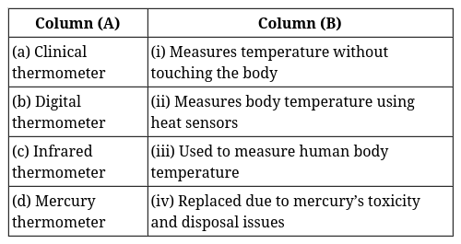 | [2]
32 | Match the Following: 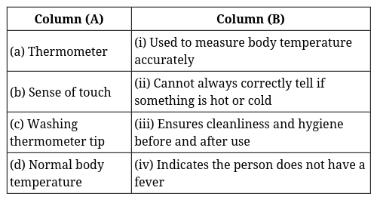 | [2]
33 | Why does the measurement location matter when using a digital thermometer? | [2]
34 | Explain the concept of temperature in terms of measuring hotness or coldness of a body. | [2]
35 | In what situations might it be essential to use a laboratory thermometer instead of a clinical one? | [2]
36 | A laboratory thermometer is not used to measure our body temperature. Give a reason. | [2]
37 | Identify and explain the role of normal body temperature in defining the health status of an individual. | [2]
38 | What are the differences between Celsius, Fahrenheit, and Kelvin temperature scales? | [2]
39 | Describe a scenario in which using a clinical thermometer would be inappropriate and explain why. | [2]
 | Section C
40 | If you have to measure the temperature 22.5$​^{o}$ C, which of the following three thermometers will you use (Fig.)? Explain.  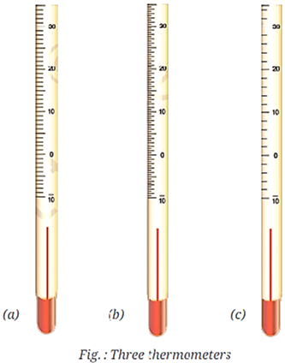 | [3]
41 | Define a clinical thermometer and explain how it measures body temperature. | [3]
42 | How do clinical and laboratory thermometers differ in their uses and methods of measuring temperature? | [3]
43 | List the characteristics that distinguish digital thermometers from mercury thermometers. | [3]
44 | Explain the relevance of the statement: ’We cannot always rely upon our sense of touch to decide correctly whether a body is hot or cold.’ | [3]
45 | Riya has not gone to office as she is ill. Her mother has kept a record of her body temperature for three days as shown in Table. Body temperature record of Riya 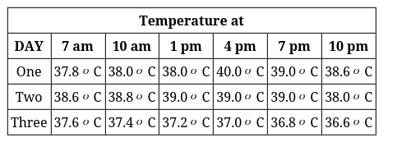  - What was Riya’s highest recorded temperature?  - On which day and at what time was Riya’s highest temperature recorded?  - On which day did Riya’s temperature return to normal? | [3]
46 | Why is a clinical thermometer unsuitable for measuring the temperature of boiling water and ice? | [3]
 | Section D
47 | Read the following text carefully and answer the questions that follow:  There are many types of laboratory thermometers but the one that might be available in your school laboratory may look like the one shown in Fig.    It consists of a long, narrow, uniform glass tube which is sealed. At one end of the tube is a bulb which contains a liquid. Outside the bulb, in the tube, a narrow column of liquid can be seen. There is a Celsius scale marked along the tube. The liquid column rises or falls with change in temperature. The mark of the Celsius scale with which the top level of the liquid column coincides is the temperature reading.  - What is the liquid inside the bulb of a laboratory thermometer used for? (1)  - Which temperature scale is marked on a laboratory thermometer? (1)  - Explain how a laboratory thermometer measures temperature. (2)  - OR  - Describe the structure of a laboratory thermometer. How does the liquid column help in measuring temperature? (2) | [4]
48 | Read the following text carefully and answer the questions that follow:  A reliable measure of hotness (or coldness) of a body is its temperature. A hotter body has a higher temperature than a colder body. The difference in temperature between the two bodies tells us how hot a body is in comparison to another body. A device that measures temperature is called a thermometer. There are two kinds of thermometers that you are likely to come across—clinical thermometers and laboratory thermometers. Clinical thermometers are used to measure human body temperatures whereas laboratory thermometers are used for many other purposes. Let us now learn more about thermometers and how to use them to measure temperature.  - What is the device used to measure temperature called? (1)  - Which thermometer is used to measure human body temperature? (1)  - What is temperature, and how is it measured? (2)  - OR  - Differentiate between a clinical thermometer and a laboratory thermometer based on their uses. (2) | [4]
49 | Read the following text carefully and answer the questions that follow:  There is another scale of temperature known as Fahrenheit scale. On this scale, the unit of temperature is degreeFahrenheit and is denoted by °F. A temperature measured as 37.0 °C on Celsius scale is equivalent to 98.6 °F on Fahrenheit scale. The Fahrenheit scale is not used in most scientific studies anymore. In scientific work, there is another scale of temperature known as Kelvin scale. On this scale, the unit for temperature is kelvin and is denoted by K. The SI unit of temperature is kelvin.  - What is the unit of temperature on the Fahrenheit scale? (1)  - What is the SI unit of temperature? (1)  - Explain why the Fahrenheit scale is not commonly used in scientific studies. (2)  - OR  - What is the Kelvin scale, and why is it important in scientific work? (2) | [4]
 | Section E
50 | Discuss the importance of washing the thermometer before and after each use, especially in a family setting or communal use. | [5]
51 | Describe the precautions that should be taken when using a thermometer to measure body temperature. Why are these steps essential for obtaining an accurate reading? | [5]
52 | What are the differences between a clinical thermometer and a laboratory thermometer? | [5]
53 | What is temperature, and why is it important to measure it? | [5]
54 | Identify and describe the differences in unit notation across Celsius, Fahrenheit, and Kelvin temperature scales. | [5]
55 | Describe how air temperature data is used in making weather forecasts. | [5]
56 | Discuss how the discovery and implementation of digital thermometers have impacted the medical field and everyday health monitoring. | [5]
 | Section F
57 | Fill in the blanks:  - The normal temperature of a human body in Fahrenheit is ________ °F.  - The unit of temperature in the Kelvin scale is________.  - Clinical thermometers are used to measure ________temperatures.  - The lowest and the highest temperature a laboratory thermometer can measure is known as its________.  - The normal temperature of a healthy human body is taken to be ________ °C.  - The Celsius scale is used for measuring temperature and the unit is denoted by ________.  - Mercury thermometers are being replaced by ________ thermometers due to safety concerns.  - We cannot always rely on our sense of ________ to determine temperature.  - A hotter body has a higher ________ than a colder body. | [9]
 | Section G
58 | State whether the given statement is True or False:  - Digital clinical thermometers display temperature readings digitally.  - The Fahrenheit scale sets the freezing point of water at 0°F.  - The normal body temperature is always 37.0°C for every person.  - "Temperature is an unreliable measure of how hot or cold a body is."  - Digital thermometers are safer than mercury thermometers because they do not contain toxic substances.  - Absolute zero is the point where molecular motion ceases and is equivalent to - 273.15 °C.  - A hotter body always has a lower temperature than a colder body.  - The Kelvin scale is primarily used for everyday temperature measurements.  - Infrared thermometers can measure temperature without direct contact.  - Clinical thermometers can be used to measure the temperature of boiling water. | [10]

